**Validation for lab 6:** [**https://lab6.jordanwentland.com**](https://lab6.jordanwentland.com)

**Index.html validation:**

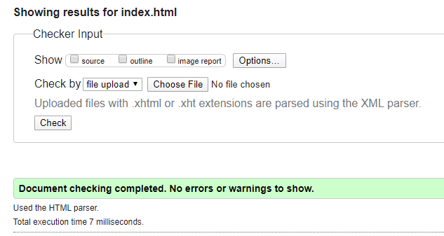

**Board.html validation:**

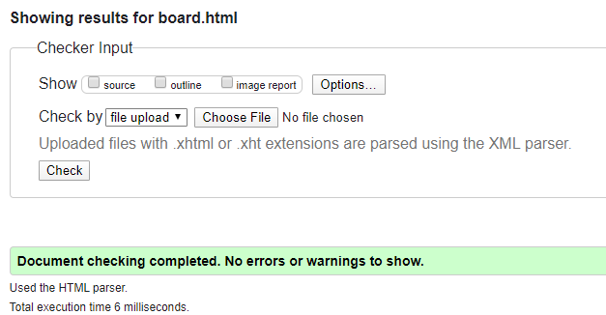

**Training.html validation:**

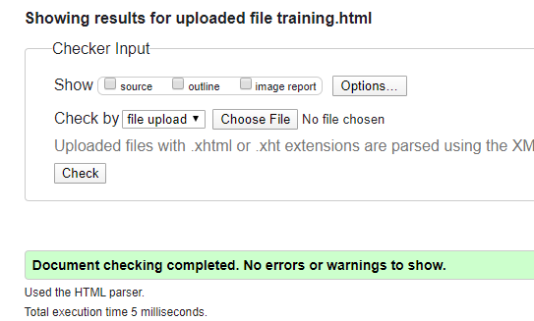

**GPST.css validation:** 